**Measure energy consumption**

**Energy consumption time series forecasting with python and LSTM deep learning model**

The objective of this article is to present in python that has a very intuitive and easy input to model and predict time series data using deep learning.

The packages that are used for deep modeling are TensorFlow and Keras.

A time series is a sequence of numerical data points in successive order. These points are often measured at regular intervals (every month, every day, every hour, etc.).The data frequency used here is hourly and it was measured from 2004–10–01 to 2018–08–03. The total number of raw data points is 121271.

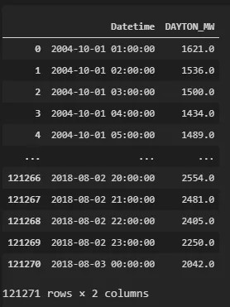

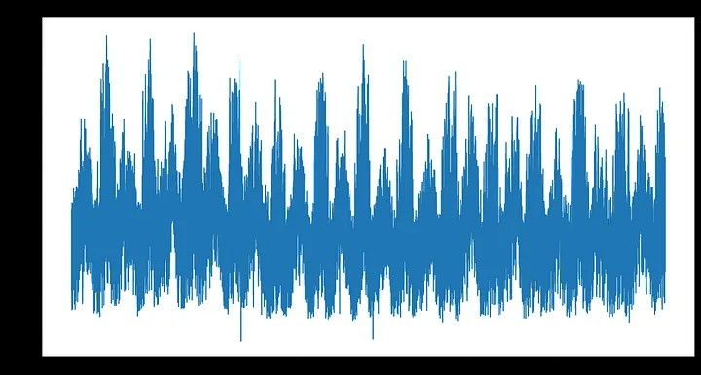Visualization of the time series

A line plot for the energy consumption time series

The main objective of the deep learning algorithm for a given time series is to find a function f such that:

Yₜ = f(Yₜ₋₁, Yₜ₋₂, …, Yₜ₋ₚ)

In other words, we want to estimate a function that explains the current values of energy consumption based on p lags of the same energy consumption.

Firstly, we need to read the data :

1 # Loading pandas

2 Import pandas as pd

3

4 # Loading date wrangling package

5 From datetime import datetime

6

7 # Reading the input data

8 D = pd.read_csv(‘input/DAYTON_hourly.Csv’)

9

10 # Formating to datetime

11 D[‘Datetime’] = [datetime.strptime(x, ‘%Y-%m-%d %H:%M:%S’) for x in d[‘Datetime’]]

12

13 # Making sure there are no duplicated data

14 # If there are some duplicates we average the data during those duplicated days

15 D = d.groupby(‘Datetime’, as_index=False)[‘DAYTON_MW’].mean()

16

17 # Sorting the values

18 d.sort_values(‘Datetime’, inplace=True)

We then need a function that converts the time series into an X and Y matrices for the deep learning model to start learning. Let us say that we want to create a function that explains current time series values using 3 lags:

Yₜ = f(Yₜ₋₁, Yₜ₋₂, Yₜ₋₃)

And we have this data:

Ts = [1621.0, 1536.0, 1500.0, 1434.0, 1489.0, 1620.0]

**The parameters for the class are:**

Data – the data used for modeling.

Y_var – the variable name we want to model/forecast.

Lag – the number of lags used for modeling.

LSTM_layer_depth – number of neurons in the LSTM layer.

Epochs – number of training loops (forward propagation to backward propagation cycles).

Batch_size – the size of the data sample for the gradient descent used in the finding of the parameters by the deep learning model. All the data is divided into chunks of batch_size sizes and fed through the network. The internal parameters of the model are updated after each batch_size of data goes forward and backward in the model.